

**SVCE** TIRUPATI

|  |  |  |
| --- | --- | --- |
| |  | | --- | | **COURSE MATERIAL** | | |
| **SUBJECT** | **MANAGEMENT SCIENCE (15A03503)** |
| **UNIT** | **1** |
| **COURSE** | **B.TECH** |
| **DEPARTMENT** | **CSE** |
| **SEMESTER** | **4-1** |
| **PREPARED BY**  **(Faculty Name/s)** | **Dr. Y. MADHAVI**  **Assistant Professor** |
| **Version** | **V-5** |
| **PREPARED / REVISED DATE** | **19-12-2020** |

BTECH_CSE-SEM 41



**SVCE** TIRUPATI

|  |  |  |
| --- | --- | --- |
|  | **TABLE OF CONTENTS – UNIT 1** |  |
| **S. NO** | **CONTENTS** | **PAGE NO.** |

|  |  |  |
| --- | --- | --- |
| **1** | **COURSE OBJECTIVES** | **1** |

|  |  |  |
| --- | --- | --- |
| **2** | **PREREQUISITES** | **1** |

|  |  |  |
| --- | --- | --- |
| **3** | **SYLLABUS** | **1** |

|  |  |  |
| --- | --- | --- |
| **4** | **COURSE OUTCOMES** | **1** |

|  |  |  |
| --- | --- | --- |
| **5** | **CO - PO/PSO MAPPING** | **2** |

|  |  |  |
| --- | --- | --- |
| **6** | **LESSON PLAN** | **2** |

|  |  |  |  |
| --- | --- | --- | --- |
| **7** | **ACTIVITY BASED LEARNING** | | **2** |
| **8** | **LECTURE NOTES** | | **2** |
|  | **1.1** | **Concept of Management** | **5** |
|  | **1.2** | **Nature and Importance of Management** | **5** |
|  | **1.3** | **Functions of Management** | **6** |
|  | **1.4** | **Evaluation of Scientific Management** | **7** |
|  | **1.5** | **Modern management,** | **7** |
|  | **1.6** | **Motivation Theories** | **8** |
|  | **1.7** | **Leadership Styles** | **11** |
|  | **1.8** | **Decision Making Process** | **14** |
|  | **1.9** | **Designing Organization Structure** | **15** |
|  | **1.10** | **Principles Organization** | **16** |
|  | **1.11** | **Types of Organization** | **17** |
| **9** | **PRACTICE QUIZ** | | **18** |
| **10** | **ASSIGNMENTS** | | **19** |
| **11** | **PART A QUESTIONS & ANSWERS (2 MARKS QUESTIONS)** | | **19** |
| **12** | **PART B QUESTIONS** | | **21** |
| **13** | **SUPPORTIVE ONLINE CERTIFICATION COURSES** | | **21** |
| **14** | **REAL TIME APPLICATIONS** | | **21** |
| **15** | **CONTENTS BEYOND THE SYLLABUS** | | **22** |
| **16** | **PRESCRIBED TEXT BOOKS & REFERENCE BOOKS** | | **22** |
| **17** | **MINI PROJECT SUGGESTION** | | **23** |

BTECH_CSE-SEM 41



**SVCE** TIRUPATI

**1.Course Objectives**   
 The objectives of this course is to

1. To understand the concepts of management.

2. To learn about management functions and principles   
 3. To understand the tools used by managers in decision situations 4. To understand the organizational structure   
**2.Prerequisites**

Students should have knowledge on   
1. Basics of management   
2. Organizational structure

**3.Syllabus**   
**UNIT 1**

**Introduction to Management:** Concept-Nature and Importance of Management, Functions-Evaluation of Scientific Management, Modern management-Motivation Theories-Leadership Styles-Decision Making Process-Designing Organization Structure Principles and Types of Organization.

**4.Course outcomes**

**On completion of this course, the students will be able to**

CO1. Students will demonstrate strong conceptual knowledge in the functional area of

management.

CO2. Students will demonstrate effective understanding of relevant functional areas of

management and its application.

CO3. Students will demonstrate analytical skills in identification and resolution of problems

pertaining to decision making and organizing.

**1**|M S - U N I T - 1

BTECH_CSE-SEM 41



**SVCE** TIRUPATI

**4.Co-PO / PSO Mapping**

|  |  |  |  |  |  |  |  |  |  |  |  |  |  |  |
| --- | --- | --- | --- | --- | --- | --- | --- | --- | --- | --- | --- | --- | --- | --- |
| **Machi ne**  **Tools** | **PO 1** | **PO 2** | **PO 3** | **PO 4** | **PO5** | **PO 6** | **PO 7** | **PO8** | **PO 9** | **P10** | **PO1 1** | **PO1 2** | **PSO 1** | **PSO 2** |

|  |  |  |  |  |
| --- | --- | --- | --- | --- |
| **CO1** | **3** | **3** | **2** | **2** |

|  |  |  |  |  |  |  |  |  |  |  |  |  |  |  |
| --- | --- | --- | --- | --- | --- | --- | --- | --- | --- | --- | --- | --- | --- | --- |
| **CO2** | **3** | **3** |  |  |  |  |  |  |  |  |  |  | **2** | **2** |

|  |  |  |  |  |
| --- | --- | --- | --- | --- |
| **CO3** | **3** | **3** | **2** | **2** |

|  |  |  |  |  |  |  |  |  |  |  |  |  |  |  |
| --- | --- | --- | --- | --- | --- | --- | --- | --- | --- | --- | --- | --- | --- | --- |
| **CO4** | **3** | **3** |  |  |  |  |  |  |  |  |  |  | **2** | **2** |

|  |  |  |  |  |
| --- | --- | --- | --- | --- |
| **CO5** | **3** | **3** | **2** | **2** |

**5.Lesson Plan**

|  |  |  |  |
| --- | --- | --- | --- |
| **Lecture No.** | **Weeks Topics to be covered** | | **References** |
| |  | | --- | | **1** | | |  |  | | --- | --- | | |  | | --- | | **Introduction to Management** | | | | |  | | --- | | **T1** | |
| |  | | --- | | **2** | | |  | | --- | | **1** | | |  |  | | --- | --- | | **Nature and Importance of Management** | **T1, R1** | | |
| |  | | --- | | **3** | |
| |  | | --- | | **Evaluation of Scientific Management** | | |  | | --- | | **T1, R1** | |
| |  |  |  | | --- | --- | --- | |  | **Modern management** | **T1, R1** | | | |
| |  | | --- | | **4** | |
| |  | | --- | | **5** | | |  |  | | --- | --- | | |  | | --- | | **Motivation Theories** | | | | |  | | --- | | **T1, R2** | |
| |  | | --- | | **6** | | |  | | --- | | **2** | | |  |  | | --- | --- | | **Functions of management** | **T1, R1** | | |
| |  | | --- | | **7** | | |  | | --- | | **Leadership Styles** | | |  | | --- | | **T1, R1** | |

|  |  |  |  |
| --- | --- | --- | --- |
| **8** |  | **Decision Making process** | **T1, R1** |

|  |  |  |  |  |
| --- | --- | --- | --- | --- |
| **9**  **Designing Organization Structure**  **T1, R1**  **3**   |  |  |  |  | | --- | --- | --- | --- | | **10** |  | **Principles and Types of Organization** | **T1, R1** | |

**7.Activity Based Learning**

**1.CASE STUDY**

**2.MANAGEMENT GAMES**

**8.Lecture Notes**

**1.1INTRODUCTION**

**2**|M S - U N I T - 1

BTECH_CSE-SEM 41



**SVCE** TIRUPATI

**Introduction to Management:**   
 **Concept-Nature and Importance of Management, Functions-Evaluation of Scientific Management, Modern management-Motivation Theories-Leadership Styles-Decision Making Process-Designing Organization Structure Principles and Types of Organization.**

**OUTCOME OBJECTIVE**   
**After studying this unit the student can understand the different Levels of Management, Functions of Corporate Managers, and fundamental knowledge of Management Science.**

**UNIT OBJECTIVE**   
**• Concept of Management**   
**• Nature and Importance of Management**   
**• Functions of Management**   
**• Evaluation of Scientific Management**   
**• Modern management,**   
**• Motivation Theories**   
**• Leadership Styles**   
**• Decision Making Process**   
**- Designing Organization Structure**   
**• Principles Organization**   
**• Types of Organization**

**Nature**   
**1.Management is goal oriented or purposive activity**   
**2.Management is group activity**   
**3.Management is a universal process or pervasive activity**   
**4.Management is multi-disciplinary**   
**5.Management is ongoing activity/continuous process**   
**6.Management is a social process**   
**7.Coordination of human and physical resources or management integrates human**  **and physical**   
**8.resources**   
**9.Activating employees**   
**10.Management is both a science and an art**

**Importance**   
▪**Achieving business objective**   
▪**Optimum use of business resources**   
▪**Effective leadership and motivation**   
▪**Effective organization and co-ordination**   
▪**Establishing clear authority and responsibility**

**3**|M S - U N I T - 1

BTECH_CSE-SEM 41



**SVCE** TIRUPATI

▪**Solution of labour problems**   
▪**Fulfilling social responsibility**

**Functions of Management**   
**1.Planning**   
**2.Organizing**   
**3.Staffing**   
**4.Directing**   
**5.Controlling**   
  **Principles of Scientific Management**   
**1.Science, Not Rule of Thumb**   
**2.Harmony, Not Discord**   
**3.Mental Revolution**   
**4.Cooperation, Not Individualism**   
**5.Development of each and every person to his or her greatest efficiency and**  **prosperity**

**Motivation Theories**

**Maslow’s Need Hierarchy Theory**   
**1.Herzberg’s Motivation Hygiene Theory**   
**2.McClelland’s Need Theory**   
**3.ALDERFER’S ERG Theory**

**Leadership styles**   
**1.Autocratic leadership**   
**2.Democratic leadership**   
**3.Laissez-faire**   
**4.Transformational leadership**   
**5.Transactional leadership**

**Decision Making Process**   
**Step 1: Identification of the purpose of the decision Step 2: Information gathering**   
**Step 3: Principles for judging the alternatives**   
**Step 4: Brainstorm and analyze the different choices Step 5: Evaluation of alternatives**

**Step 6: Select the best alternative**   
**Step 7: Execute the decision**   
**Step 8: Evaluate the results**

**4**|M S - U N I T - 1

BTECH_CSE-SEM 41



**SVCE** TIRUPATI

**Designing Organization Structures**   
**The main objective of an organization structure is to ensure that efforts of all the people working in various sections are co-ordinate and integrated for achieving the task in the most efficient effective way with minimum consumption of resources i.e.**

**economical ways**

**1) Formal organization structure**   
**2) Informal organization structure**

**Principles of Organization**   
**1.Principle of co-ordination**   
**2.Principles of organizational efficiency**   
**3.Span of management principle**   
**4.Scalar principle**   
**5.Principle of responsibility**   
**6.Principle of parity of authority and responsibility 7.Principle of unity command**   
**8.Authority level principle**   
**9.Principle of balance**   
**10.Principle of flexibility**

**Types of Organization**   
 **On the basis of authority relationships organization classified as follows: 1. Line organization or Military organization or Scalar organization 2. Functional organization**

**3. Line and Staff organization**   
**4. Project organization**   
**5. Committee organization**   
**6. Matrix organization**

**Introduction to Management:**   
**When human being started group activities for the attainment of same common objectives whenever a group is formed and a group activity is organized to**   
**achieve certain common objectives management is needed to direct, co-ordinate and integrate the individual activities of a group and secure teams work to**   
**accomplish organizational objectives. The objectives of all business are attained by utilizing the scare resources like men, materials, machines, money etc.**

**In process of management, a manage uses human skills, material resources and scientific methods to perform all the activities leading to the achievement of goods.**

**CONCEPT OF MANAGEMENT**   
**"Management is the coordination of all resources through the process of planning, organising, directing and controlling in order to attain stated goals."**

**5**|M S - U N I T - 1

BTECH_CSE-SEM 41



**SVCE** TIRUPATI

**1. “To manage is to forecast, to plan, to organise, to command, to co-ordinate and to control.” —Henry Fayol.**

**It attempts to describe management in terms of what a manager does, and not what management is.**

**2. “Management is a multipurpose organ that manages a business and manages manager, and manages worker and work.”— P. Drucker: The Practice of**   
**Management**   
**(i) Managing a business;**

**(ii) Managing manager; and**   
**(iii) Managing workers and work.**

**DEFINITION of MANAGEMENT**

**Management is an art of getting things done through by others with the help of planning, organising, staffing, directing and controlling functions to achieve an individual/group goals and objectives.**

**“Management is knowing exactly what you want men to do and then seeing that they do it the best and cheapest ways”. By __F.W.Taylor**   
**“Management is defined as the creation and maintenance of an internal**   
**environment in an enterprise where individuals working together in groups, can perform efficiently and effectively towards the attainment of group goals”. BY __Koontz and O’Donell**

**Planning: Involves selecting the objectives and actions to achieves them planning stage involves decision making and choosing future courses of action from the various alternatives**

**Organizing: Role of each person in any organization is fixed. The concept of role is who will be doing what should be known, to achieve organizational targets**   
**efficiently. It is intended that all the tasks necessary to achieve targets are assigned to people who can do the best.**

**Staffing: Staffing function includes keeping the various organizational position fixed. This activity is done by identifying work force requirements, keeping the records of the performance of people working with the organization. So that suitable people can be prompted and at the same time people performing not up to the mark could be send for training.**

**Directing: Directing means influencing people, so that they will contribute to the organization targets directing involves motivation, leadership styles and proper communication.**

**Controlling: It is the process of comparing the plans with the results. If there is deviation attain taken to be bridge the gap between plan and actual results.**

**6**|M S - U N I T - 1

BTECH_CSE-SEM 41

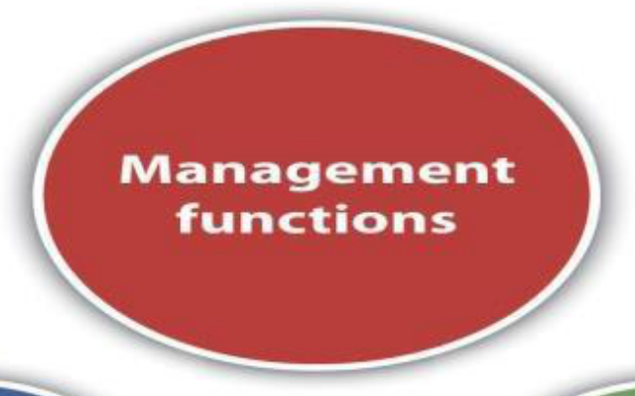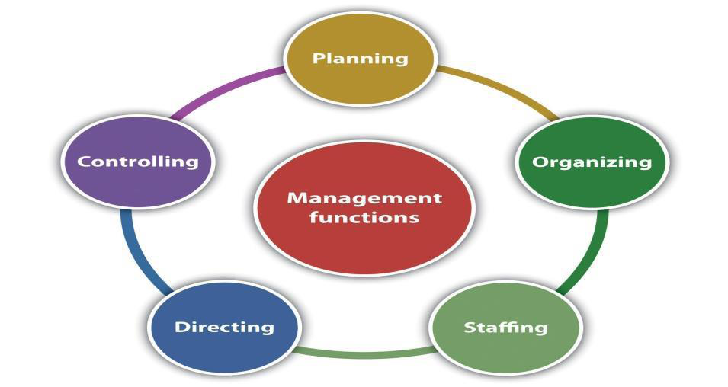

**SVCE** TIRUPATI

**PRINCIPLES OF MANAGEMENT**

**1. Division of work - The division of work is the course of tasks assigned to, and completed by, a group of workers in order to increase efficiency. Division of work, which is also known as division of labour, is the breaking down of a job so as to have a number of different tasks that make up the whole.**

**2. Authority and Responsibility - Authority is the right to give orders and obtain obedience, and responsibility is the corollary of authority.**

**3. Discipline - Employees must obey and respect the rules that govern the organization. Good discipline is the result of effective leadership.**

**4. Unity of command - Every employee should receive orders from only one superior or behalf of the superior.**

**5. Unity of direction - Each group of organizational activities that have the same objective should be directed by one manager using one plan for achievement of one common goal.**

**6. Subordination - The interests of any one employee or group of employees should not take precedence over the interests of the organization as a whole.**

**7. Remuneration - All Workers must be paid a fair wage for their services.**

**8. Centralisation and decentralisation - Centralisation refers to the degree to which subordinates are involved in decision making.**

**9. Scalar chain - The line of authority from top management to the lowest ranks represents the scalar chain. Communications should follow this chain.**

**10. Order - this principle is concerned with systematic arrangement of men, machine, material etc. There should be a specific place for every employee in an organization**

**11. Equity - Managers should be kind and fair to their subordinates.**

**7**|M S - U N I T - 1

BTECH_CSE-SEM 41

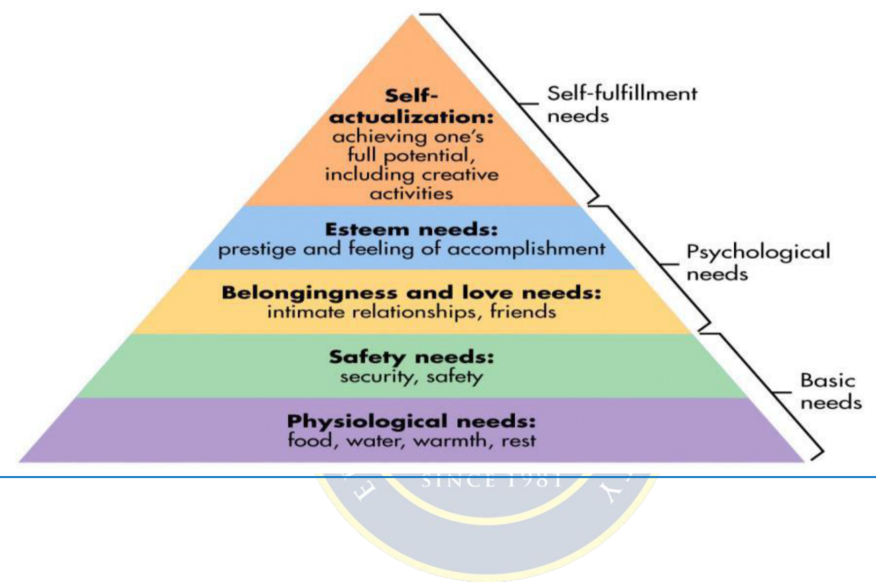

**SVCE** TIRUPATI

**12. Stability of tenure of personnel - High employee turnover is inefficient.**

**Management should provide orderly personnel planning and ensure that replacements are available to fill vacancies.**

**13. Initiative - Employees who are allowed to originate and carry out plans will exert high levels of effort.**

**14. Espirit de corps- Team work**

**Motivational theories**

**Maslow’s Need Hierarchy Theory:**

**8**|M S - U N I T - 1

BTECH_CSE-SEM 41



**SVCE** TIRUPATI   
 **Herzberg’s Motivation Hygiene Theory**

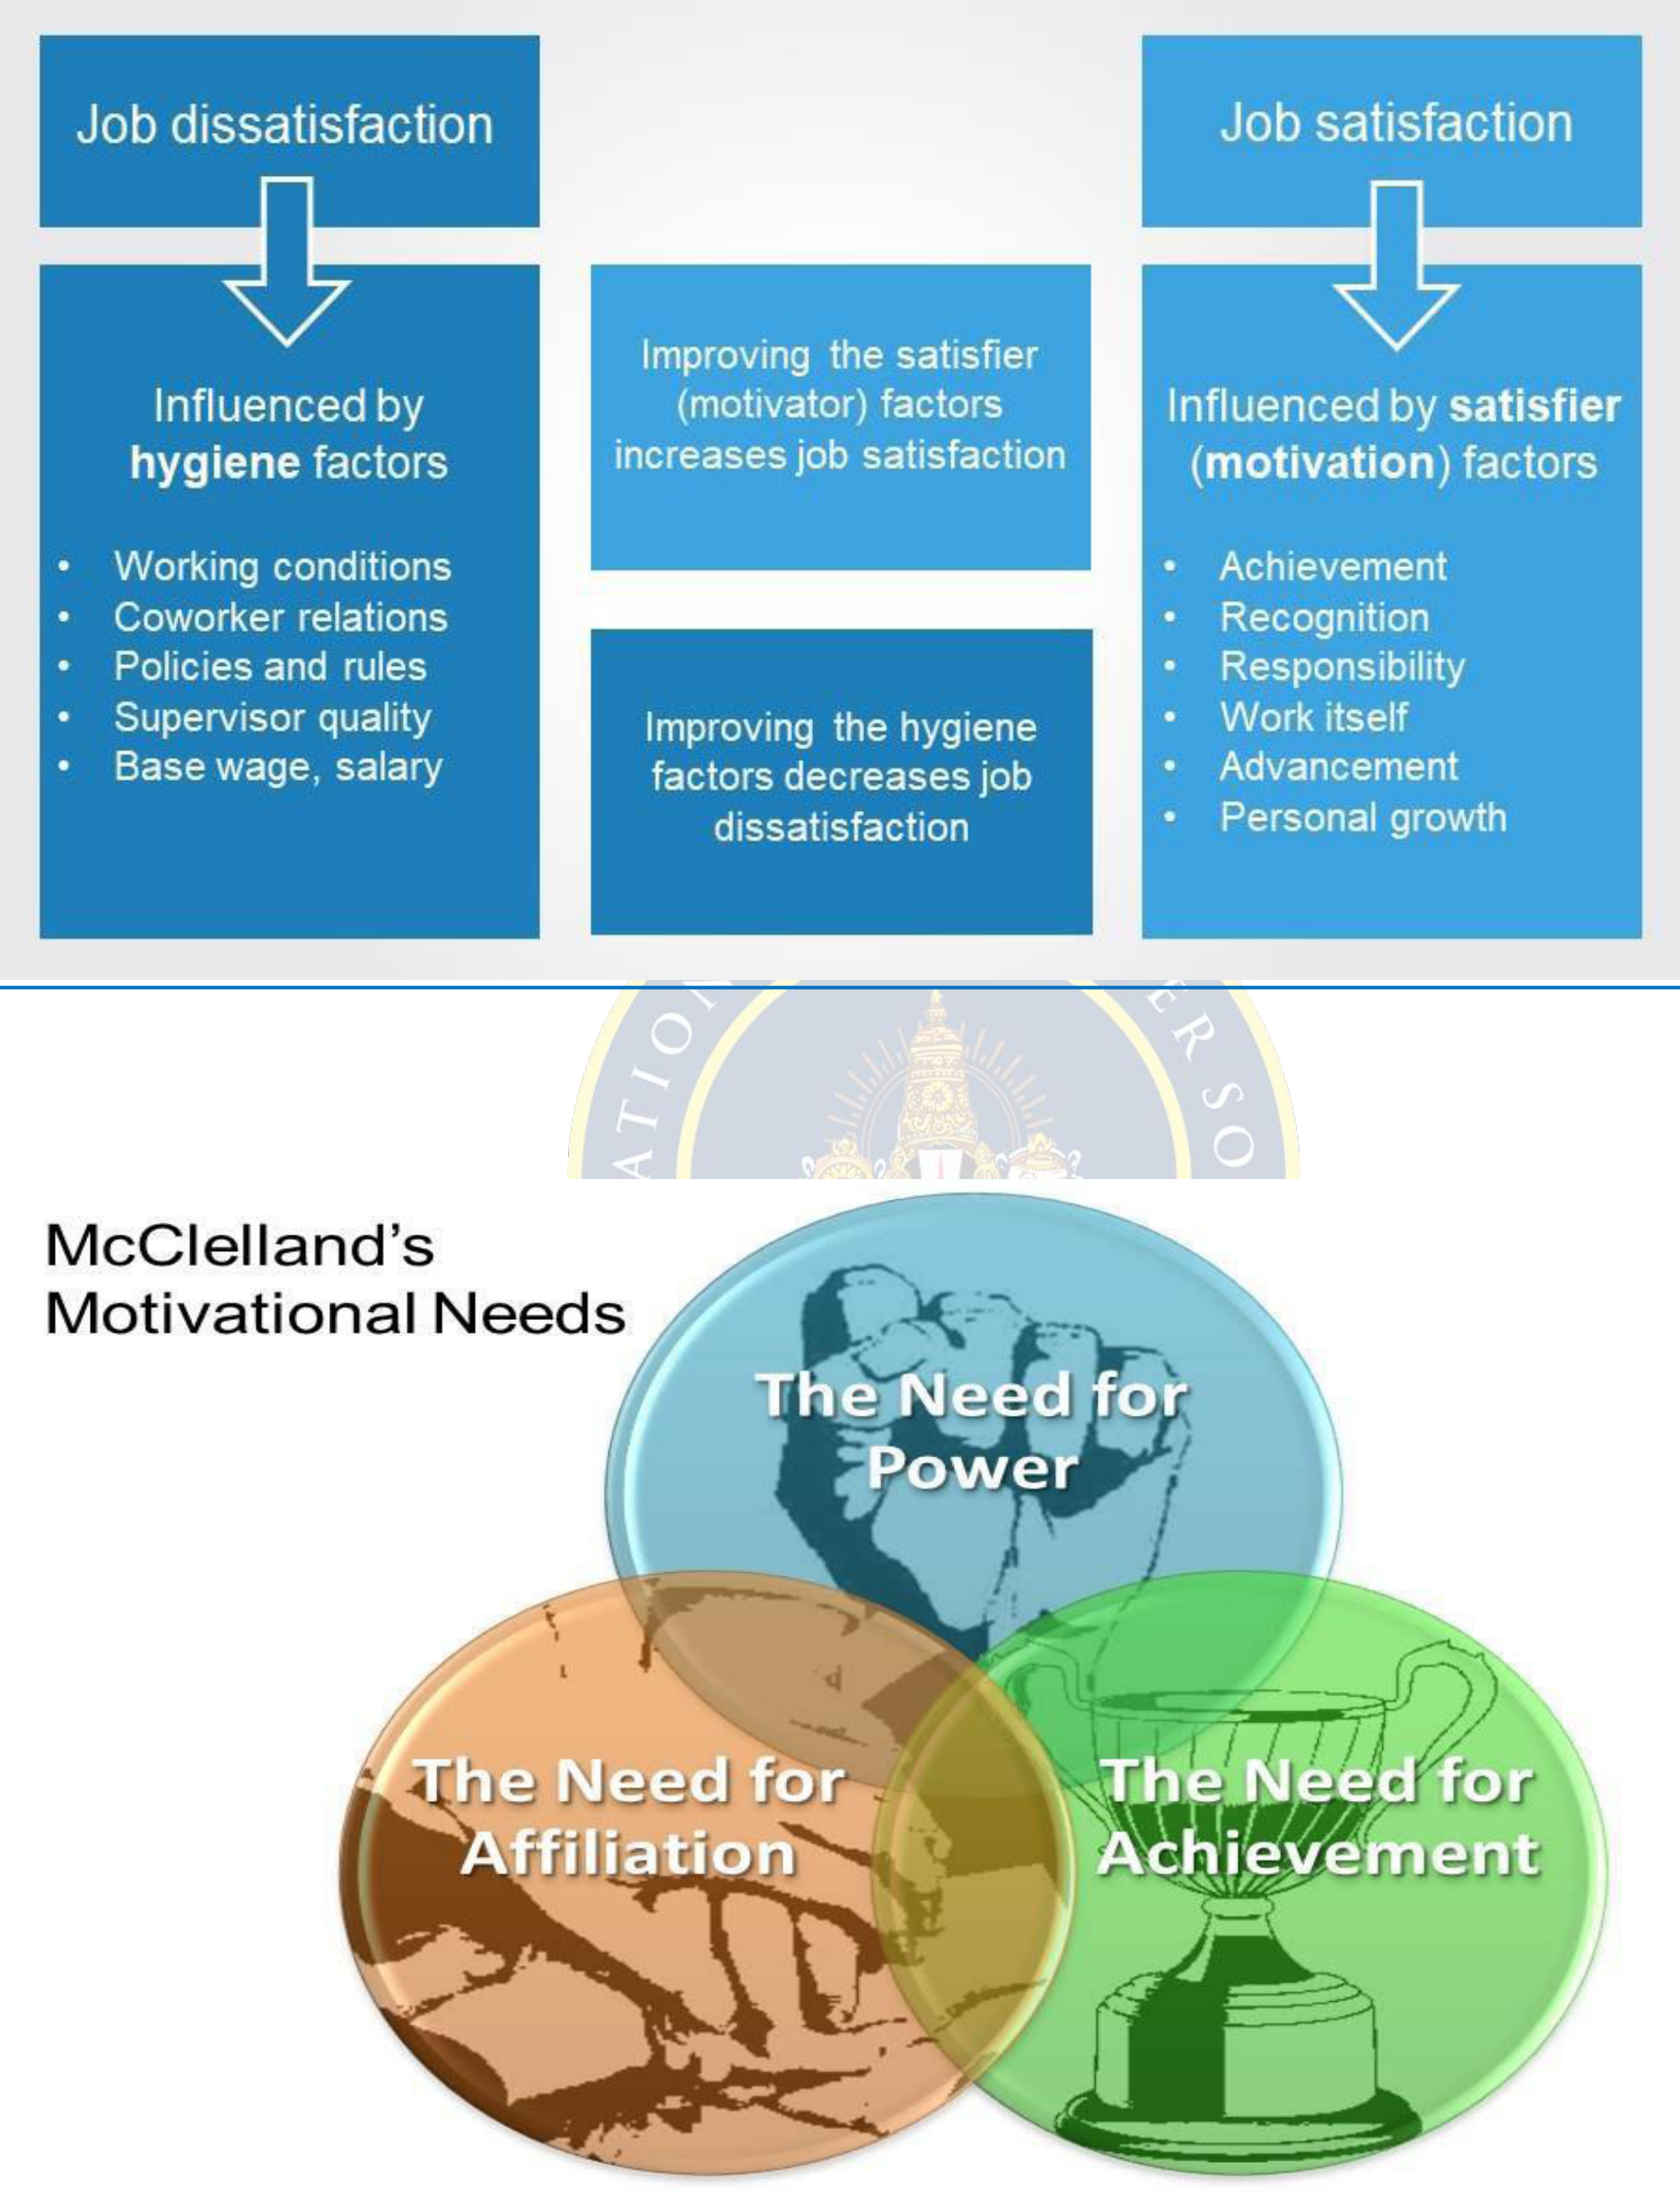

**9**|M S - U N I T - 1

BTECH_CSE-SEM 41

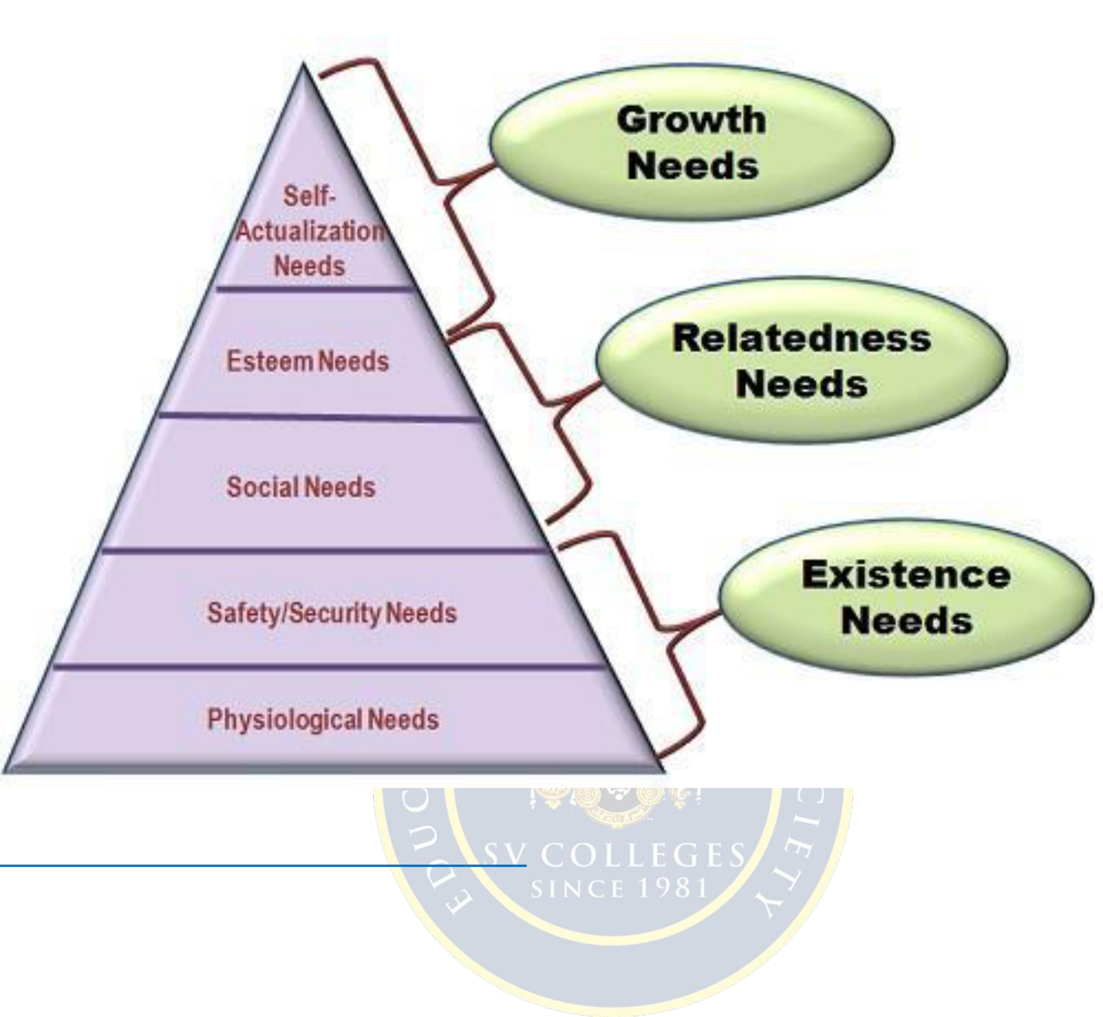

**SVCE** TIRUPATI

**ALDERFER’S ERG Theory**

**LEADERSHIP AND STYLES OF LEADERSHIP**

**LEADERSHIP: Leadership is both a research area and a practical skill encompassing the ability of an individual or organization to "lead" or guide other individuals, teams, or entire organizations.**

**Definition: Leadership can be described as the ability of an individual to influence, motivate, and enable others to contribute toward the effectiveness and success of an organization or group of which they are members. A person who can bring about change, therefore, is one who has this ability to be a leader**

**10**|M S - U N I T - 1

BTECH_CSE-SEM 41



**SVCE** TIRUPATI

**Qualities of Successful leader**

▪**Honesty**   
▪**Delegate**   
▪**Communication**   
▪**Confidence**   
▪**Commitment**   
▪**Positive Attitude**   
▪**Creativity**   
▪**Intuition**   
▪**Inspire**

**Types of Leadership Styles**

**11**|M S - U N I T - 1

BTECH_CSE-SEM 41

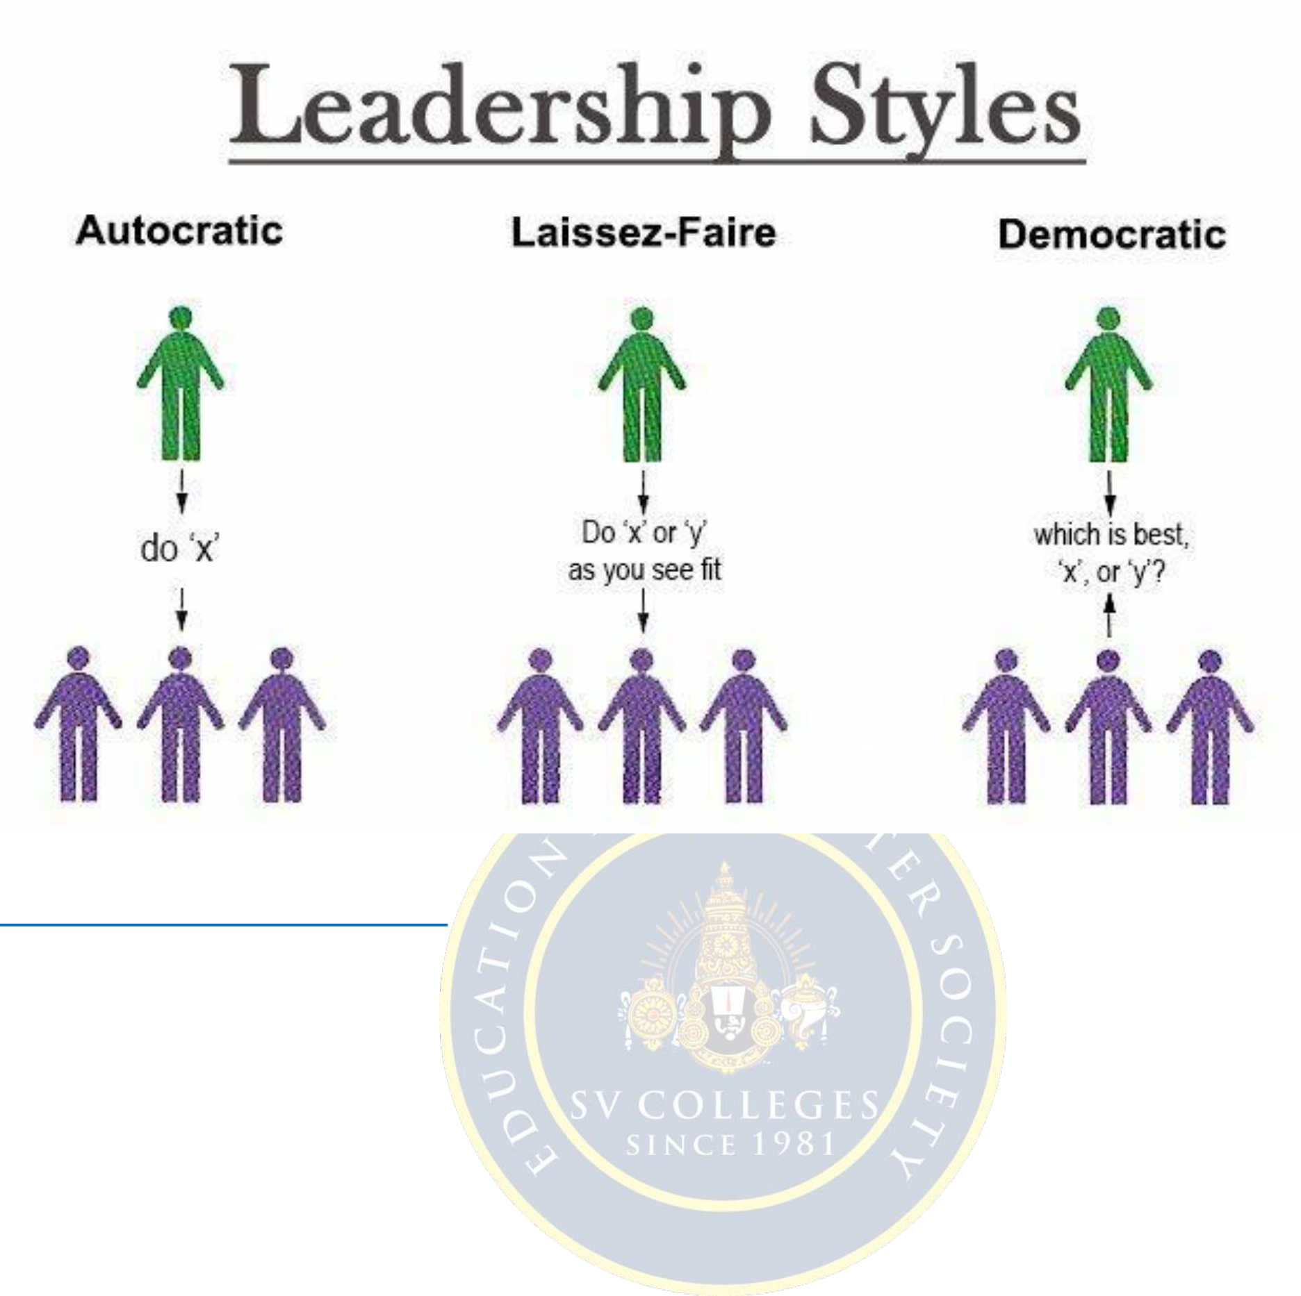

**SVCE** TIRUPATI

**Transformational Leadership**

**There are 4 components to transformational leadership, sometimes referred to as the 4 I's:**

**· Idealized Influence (II) - the leader serves as an ideal role model for followers; the leader "walks the talk," and is admired for this.**

**· Inspirational Motivation (IM) - Transformational leaders have the ability to inspire and motivate followers. Combined, these first two I's are what constitute the transformational leader's charisma.**

**· Individualized Consideration (IC) - Transformational leaders demonstrate genuine concern for the needs and feelings of followers. This personal attention to each follower is a key element in bringing out their very best efforts.**

**· Intellectual Stimulation (IS) - the leader challenges followers to be innovative and creative. A common misunderstanding is that transformational leaders are "soft," but the truth is that they constantly challenge followers to higher levels of**   
**performance. Transformational leadership is said to have occurred when**   
**engagement in a group results in leaders and followers raising one another to increased levels of motivation and morality**   
**Transactional leadership:**   
 **Transactional leadership is a part of a style of leadership that focuses on**   
**supervision, organization, and performance; it is an integral part of the Full Range Leadership Model. Transactional leadership is a style of leadership in which leaders promote compliance by followers through both rewards and punishments. Unlike**

**12**|M S - U N I T - 1

BTECH_CSE-SEM 41

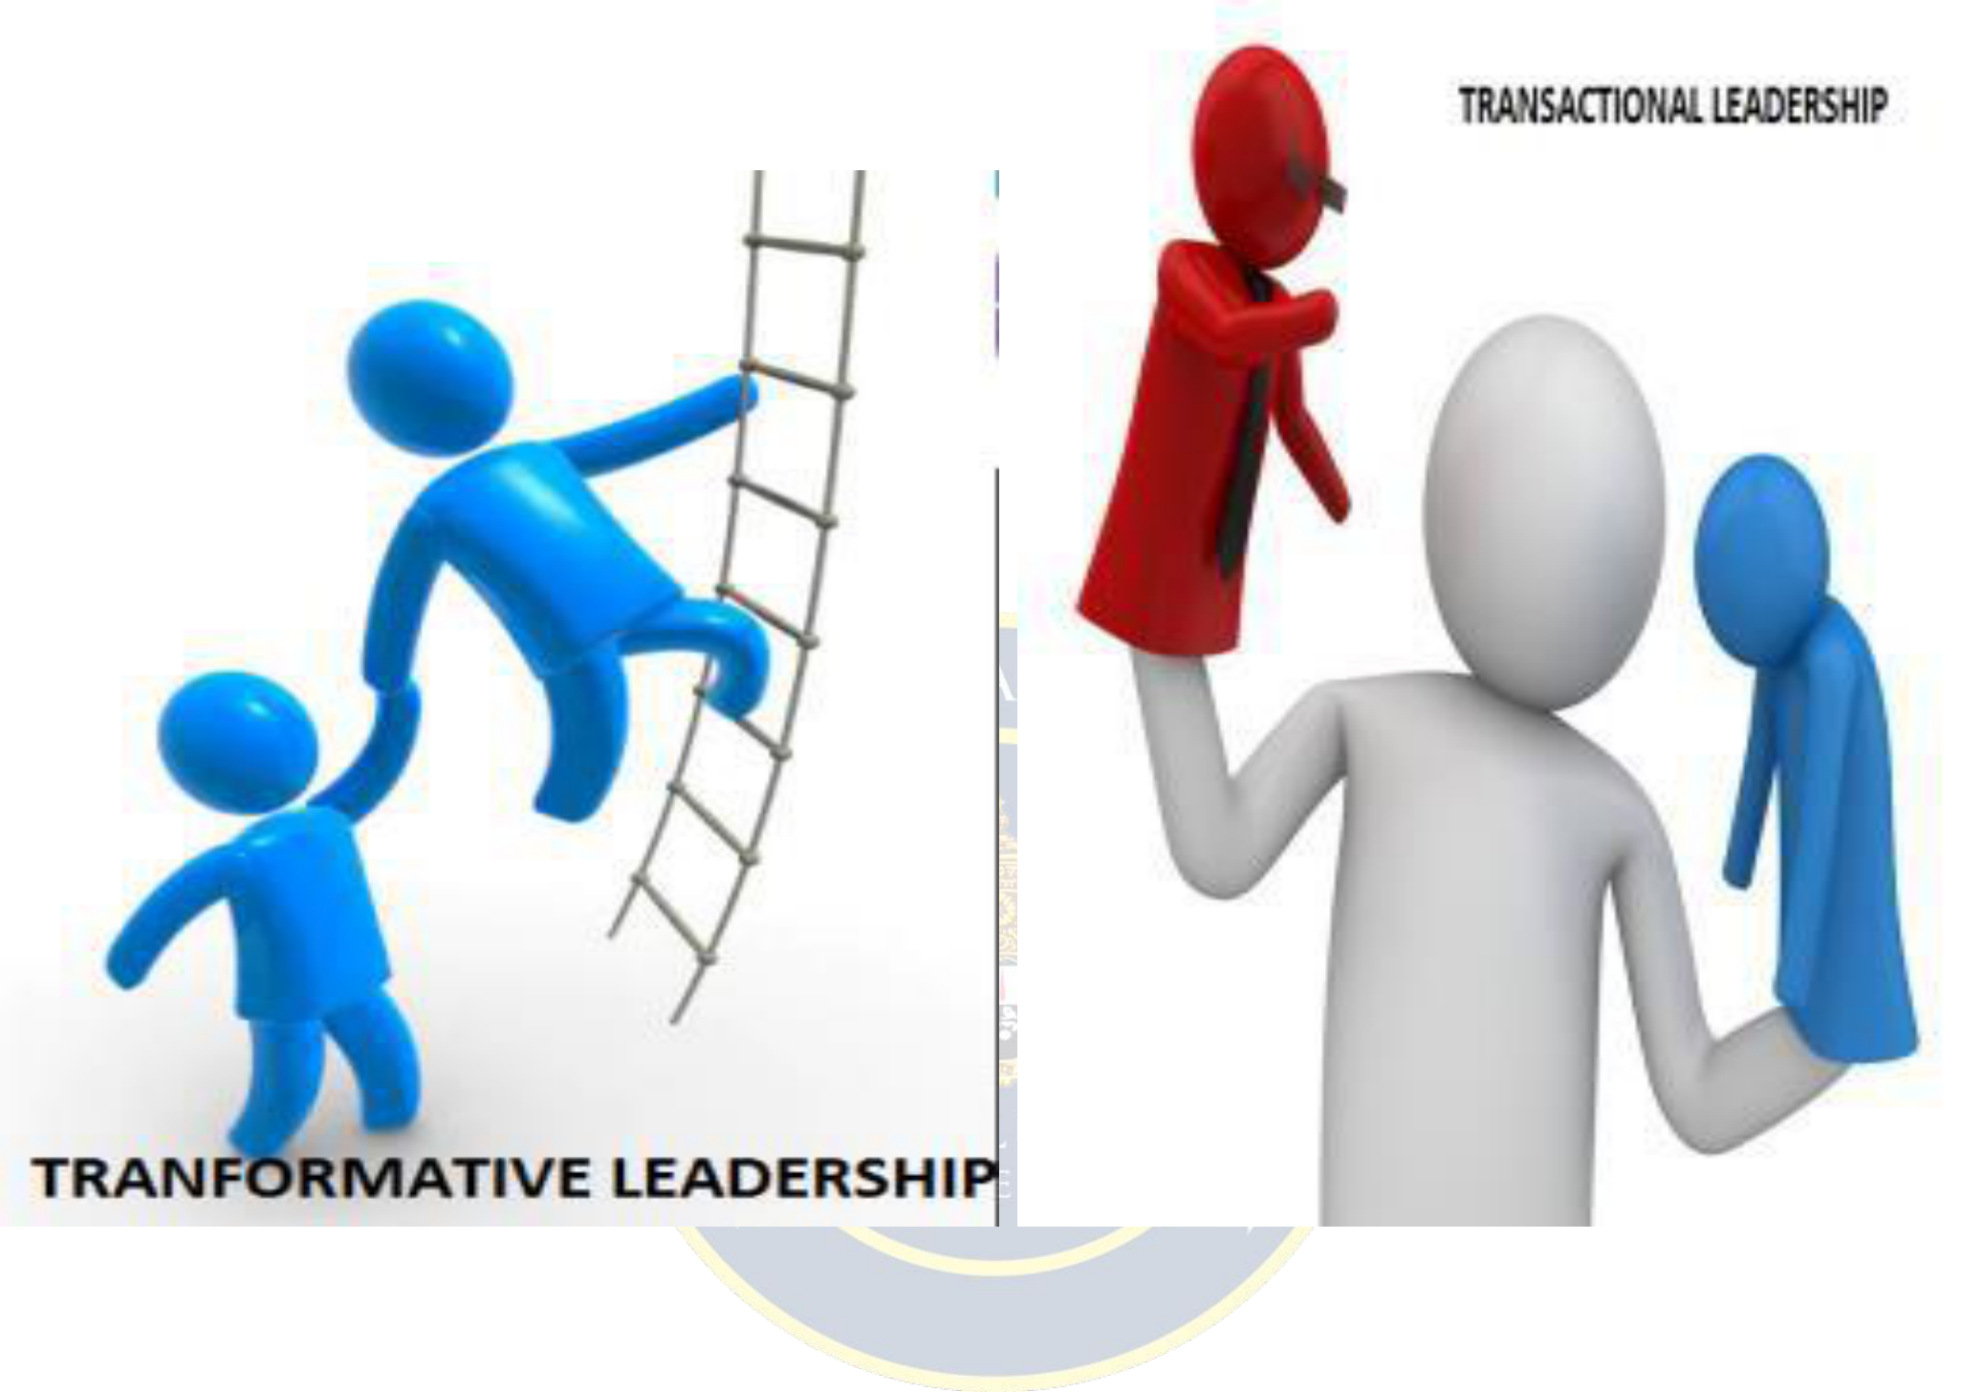

**SVCE** TIRUPATI

**transformational leaders, those using the transactional approach are not looking to change the future, they look to keep things the same. Leaders using transactional leadership as a model pay attention to followers' work in order to find faults and deviations.**

**This type of leadership is effective in crisis and emergency situations, as well as for projects that need to be carried out in a specific way.**

**13**|M S - U N I T - 1

BTECH_CSE-SEM 41

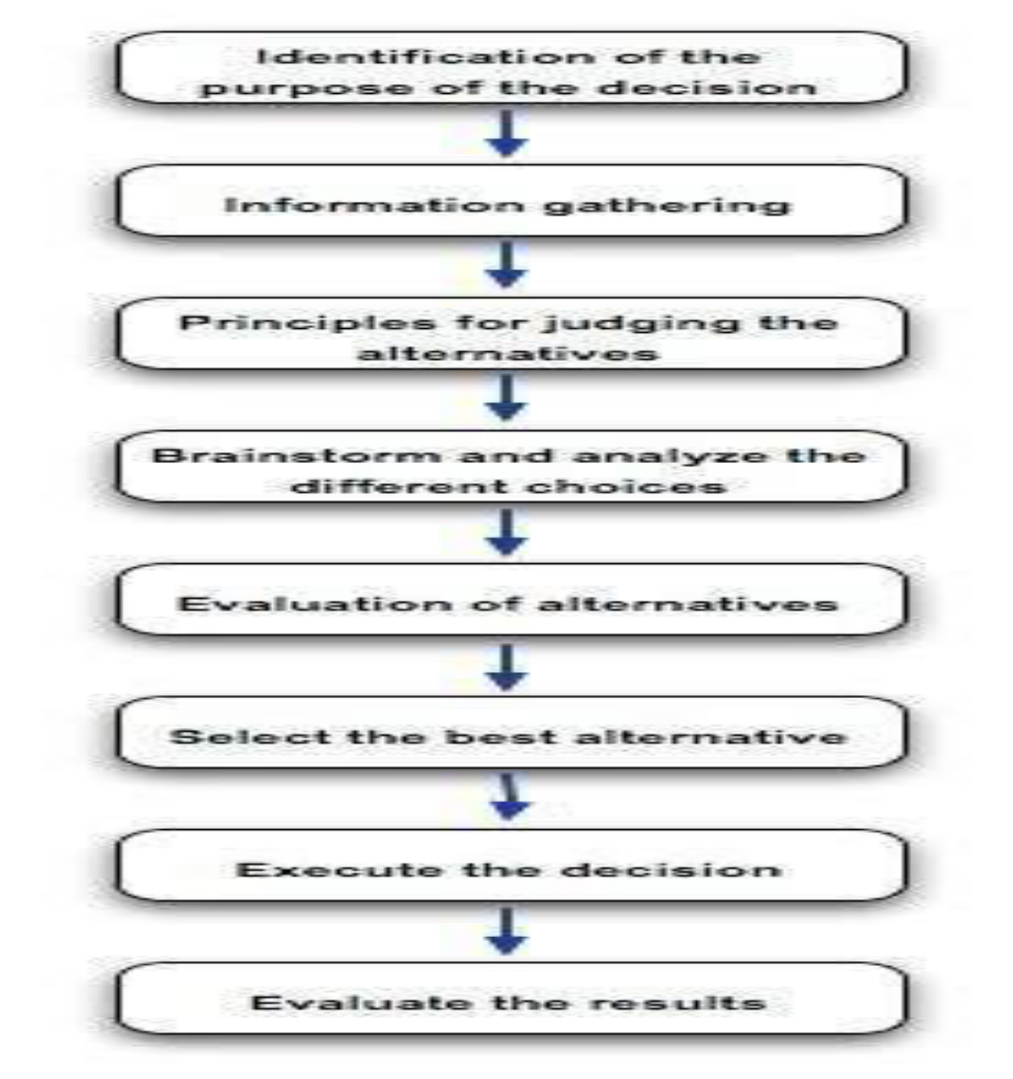

**SVCE** TIRUPATI   
 **Decision making process**

**14**|M S - U N I T - 1

BTECH_CSE-SEM 41

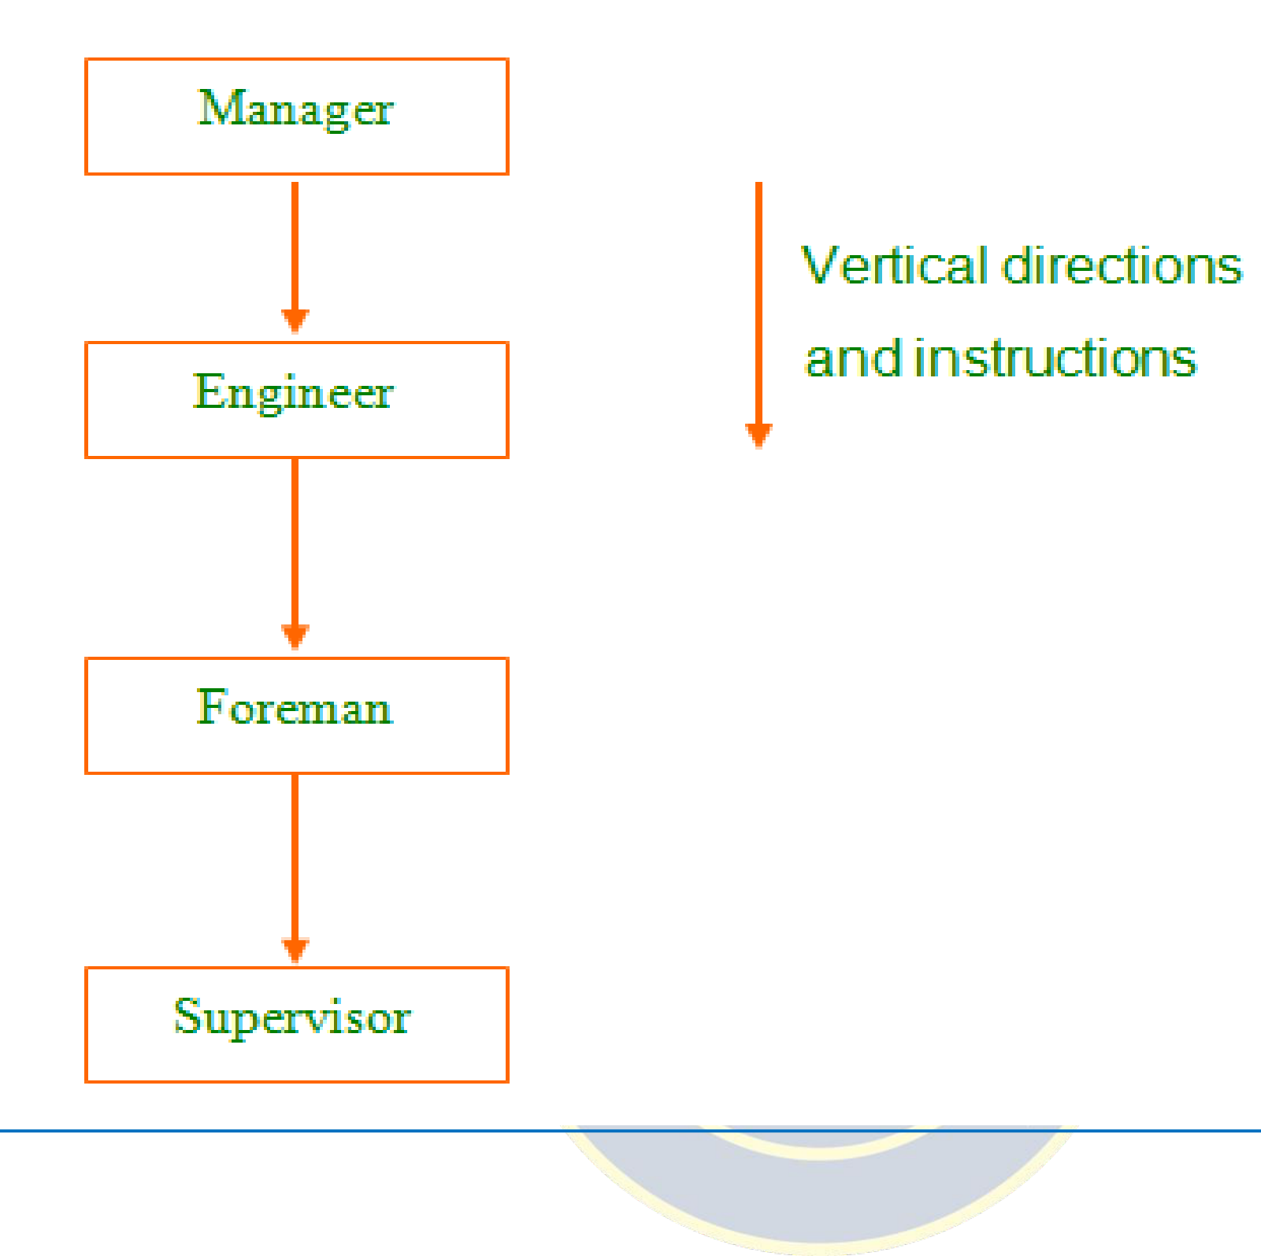

**SVCE** TIRUPATI

**LINE ORGANIZATION STRUCTURE**

**15**|M S - U N I T - 1

BTECH_CSE-SEM 41

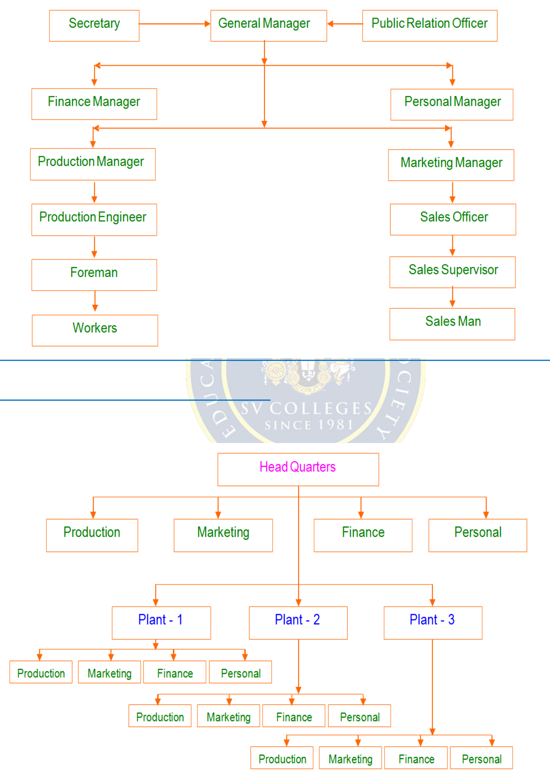

**SVCE** TIRUPATI   
 **LINE AND STAFF ORGANIZATION STRUCTURE**

**FUNCTIONAL ORGANIZATION STRUCTURE**

**16**|M S - U N I T - 1

BTECH_CSE-SEM 41

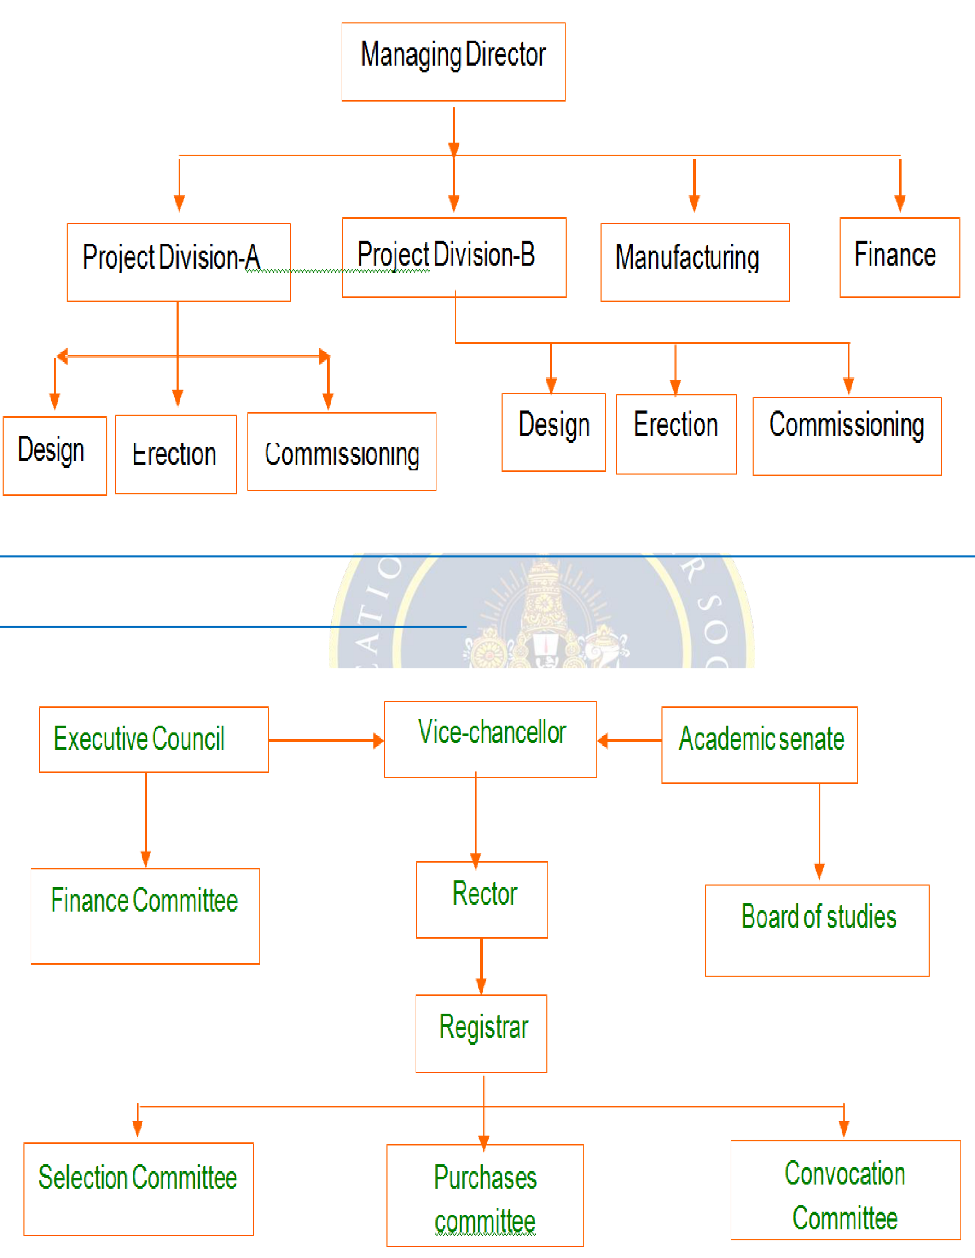

**SVCE** TIRUPATI

**PROJECT ORGANIZATION STRUCTURE**

**COMMITTEE ORGANIZATION STRUCTURE**

**17**|M S - U N I T - 1

BTECH_CSE-SEM 41

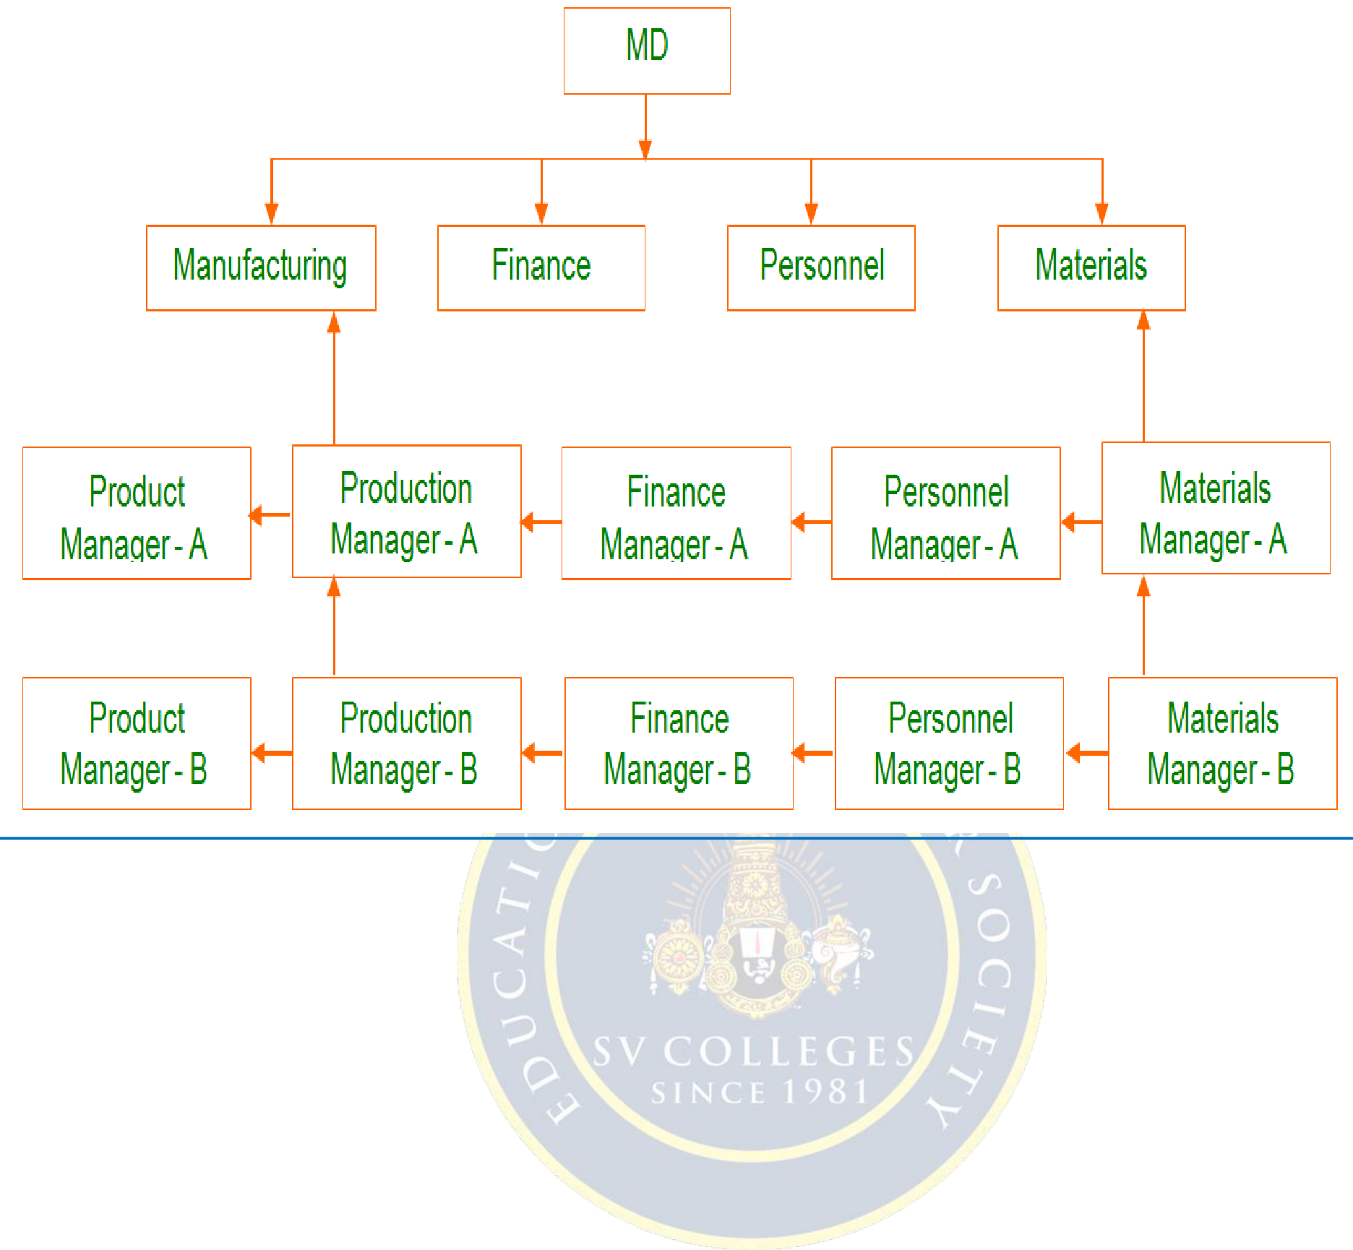

**SVCE** TIRUPATI

**MATRIX ORGANIZATION STRUCTURE**

**9.Practice Quiz**   
 **1.The framework of an establishment is called _________**   
 **A.Management**   
 **B.Organization**   
 **C.Staffing**   
 **D.None**   
**2. Who said this—“To manage is to forecast and plan, to command, to coordinate and control”**   
 **(a)E.L.F.Brech (b)W.F.G.Glueck (c)Henri Fayol**  **(d)Peters.Drucker**   
**3. According to Henry Fayol, management process covers all except**

|  |  |  |
| --- | --- | --- |
| **(a)Organising** | **(b)commanding (c)Ordinating** | **(d)Controlling** |

**4. Who is regarded as the Father of Scientific Management?**

|  |  |  |  |
| --- | --- | --- | --- |
| **a)Henri Fayol** | **(b)McGregor** | **(c)F.W.Taylor** | **(d)Charles Babbage** |

**5. The process of transferring authority from the top to bottom levels in the organization (a)Authority (b)Delegation (c)Power**  **(d)Responsibilty**

**6.What does ‘espirit de corps’ stand for?**

**(a)Team work**  **(b) right thing in the right place (c) initiation (d) avoiding frequent transfers**

**18**|M S - U N I T - 1

BTECH_CSE-SEM 41



**SVCE** TIRUPATI

**7. What is the process of classifying the organization on the basis of similar activities?**

**(a)Formulation**  **(b)departmentation (c)execution (d)implementation**

**8. ‘Deciding in advance what is to be done in future’ is called………………………….**

|  |  |  |
| --- | --- | --- |
| **(a)Organising** | **(b)commanding (c)Planning** | **(d)Controlling** |

**9. The project organization is also called.............................**

**(a)Matrix organization**  **(b) Functional organization (c) Committee organization**

**(d)None**

**10. 14 principles developed by**

|  |  |  |  |
| --- | --- | --- | --- |
| **a)Henri Fayol** | **(b)McGregor** | **(c)F.W.Taylor** | **(d)Charles Babbage** |

**1.Assignments**

|  |  |  |  |
| --- | --- | --- | --- |
| **S.No** | **Question** | **BL** | **CO** |

|  |  |  |  |
| --- | --- | --- | --- |
| **1** | **Describe the importance of management.** | **2** | **1** |
| |  |  |  | | --- | --- | --- | | **2** | **Elaborate the evolution and development of Management thought in chronological order** | **3** | | | | |  | | --- | | **2** | |
| **3** | **What is the relationship between Management and** | **2** | **1** |
| **Organization?** |

|  |  |  |  |
| --- | --- | --- | --- |
| **4** | **Explain functions of management** | **2** | **2** |

|  |  |  |  |
| --- | --- | --- | --- |
| **5** | **Define organizational structure and its purpose** | **3** | **1** |

|  |  |  |  |
| --- | --- | --- | --- |
| **6** | **Explain about types of organizational structure** | **3** | **2** |

**11. Part A- Question & Answers**

|  |  |  |  |
| --- | --- | --- | --- |
| **S.No** | **Question& Answers** | **BL** | **CO** |

|  |  |
| --- | --- |
| **1** | **Define Management?** |

**Ans. Management is the coordination of all resources**

**through the process of planning, organising, directing**

**and controlling in order to attain stated goals."**

|  |  |  |
| --- | --- | --- |
| **1. “To manage is to forecast, to plan, to organise, to** | **1** | **1** |

**command, to co-ordinate and to control.” —Henry Fayol.**

**It attempts to describe management in terms of what a**

**manager does, and not what management is.**

|  |  |  |  |
| --- | --- | --- | --- |
| **2** | **Define Scientific management**  **Scientific management is a theory of management that**  **analyzes and synthesizes workflows. Its main objective is**  **improving economic efficiency, especially labor productivity. It was one of the earliest attempts to apply science to the** | **1** | **1** |

**19**|M S - U N I T - 1

BTECH_CSE-SEM 41



**SVCE** TIRUPATI

**engineering of processes to management.**

**3**  **What are the Functions of Management?**  **1.Planning**

**2.Organizing**

|  |  |  |
| --- | --- | --- |
| **3.Staffing** | **3** | **2** |

**4.Directing**   
**5.Controlling**

**4**  **What are the needs or Objectives of Modern Management.**

**Modern management, also**

|  |  |  |
| --- | --- | --- |
| **called modern endpoint management, is the process** | **3** | **1** |
| **for managing legacy and modern applications in a unified way** |

**by providing enhanced oversight, security, and awareness to IT**

**departments.**

**5**  **What is motivation in management?**

**Effective managers have the ability to motivate those they work**

**with to behave in a specific, goal-directed way. Motivation is**

|  |  |  |
| --- | --- | --- |
| **defined as energizing, directing and sustaining employee** | **1** | **1** |

**efforts. A motivated team should be energized and excited about performing tasks**

|  |  |  |  |  |
| --- | --- | --- | --- | --- |
| **6** | **What are the important theories in Management?** | | **1** | **1** |
| **7** | • | **Maslow's Need Hierarchy Theory:** |
| • | **Herzberg's Motivation Hygiene Theory:** |
| • | **McClelland's Need Theory:** |
| **Importance of leadership in business?** | |

**Leadership in business is the capacity of a**

|  |  |  |
| --- | --- | --- |
| **company's management to set and achieve challenging goals,** | **2** | **1** |
| **take fast and decisive action when needed, outperform the** |

**competition, and inspire others to perform at the highest level they can.**

|  |  |  |  |
| --- | --- | --- | --- |
| **8** | **What are the 3 types of leadership?** | **2** | **1** |
| **Kurt Lewin was an early 20th century psychologist who** |
| **identified three specific types of** |

**leadership; authoritarian, democratic and laissez-faire**

**9**  **Purpose of decision making in management.**

**Decision-making is an integral part of modern management.**

|  |  |  |
| --- | --- | --- |
| **... Decisions play important roles as they determine both** | **2** | **1** |
| **organizational and managerial activities. A decision can be** |

**defined as a course of action purposely chosen from a set of**

**alternatives to achieve organizational or managerial objectives**

**20**|M S - U N I T - 1

BTECH_CSE-SEM 41



**SVCE** TIRUPATI

**or goals.**

**10**  **Explain the term organizational structure**   
 **An organizational structure is a system that outlines how certain**

|  |  |  |
| --- | --- | --- |
| **activities are directed in order to achieve the goals of** | **2** | **1** |
| **an organization. These activities can include rules, roles, and** |

**responsibilities. The organizational structure also determines how information flows between levels within the company.**

**12.Part B- Questions**

|  |  |  |  |
| --- | --- | --- | --- |
| **S.No** | **Question** | **BL** | **CO** |

|  |  |  |  |
| --- | --- | --- | --- |
| **1** | **‘A good leader need not necessarily be a good manager’ – In** | **4** | **1** |

|  |
| --- |
| **the light of the above statement compare leadership with** |

|  |  |  |  |
| --- | --- | --- | --- |
| **management.** | | | |
| |  | | --- | | **2** | | |  | | --- | | **Discuss about various motivational theories.** | | |  |  | | --- | --- | | **2** | **2** | | |
| **3** | **Outline the significance of Taylor’s scientific management** | **2** | **1** |
| |  |  |  | | --- | --- | --- | | **4** | **Discuss about decision making process** | **3** | | | | |  | | --- | | **1** | |
| **5** | **What are the steps involved for designing an organization** | **3** | **2** |

|  |
| --- |
| **structure? Explain.** |

**13.Supportive Online Certification Courses**   
**1.Operations management Bychristianterwiesch conducted by Wharton-4weeks. 2.Analysis and improvement methods by uddattapalekhar conducted by ILLINOIS –**  **12 weeks.**

**14. Real Time Applications**

|  |  |  |
| --- | --- | --- |
| **S.No** | **Application** | **CO** |

|  |  |  |
| --- | --- | --- |
| **1** | **Process and technology selection** | **1** |

|  |  |  |
| --- | --- | --- |
| **2** | **Manufacturing resources planning** | **2** |

|  |  |  |
| --- | --- | --- |
| **3** | **Total productive maintenance** | **1** |

|  |  |  |
| --- | --- | --- |
| **4** | **Supplier selection and evaluation** | **3** |

**15. Contents Beyond the Syllabus**

•**The list is accumulated after through research to assist you with the best dissertation topics in management. You can select any of them and modify a bit to make an absolutely new topic for your research. By adding specific sector, industry, or**

**21**|M S - U N I T - 1

BTECH_CSE-SEM 41



**SVCE** TIRUPATI

**country can help you make the topic more focused. Either you are pursuing an undergraduation student looking for dissertation topics in management.**

•**Evaluation of the management function in the UK service sector.**

•**A review on the identification of risk and management of disaster through**  **management literature.**

•**A comparative analysis of operations management for products and services.** •**A comparative analysis of the different forecasting methodologies used in decision**  **making process.**

•**A systematic review of current mediation models in modern management literature.** •**An analysis of provisional strategies for management of quality failure in oil and gas**  **operations management.**

•**How does management decide whether to manufacture in house or outsource?**  **Lessons from the textile industry.**

•**A systematic review of the practical efficacy of Resource Based Theory in strategic**  **operations management.**

•**A review of the scope of operations management in the finance sector of UK's**  **healthcare systems.**

•**An analysis of the tools and models used in operations management and their**  **contribution to management quality.**

•**Can operations management strategies effectively cater to Home Care**  **Organization requirements? A global perspective.**

•**Operations management in times of crisis- a review of possibilities based on current**  **literature.**

•**A review of the most prevalent research methods employed in operations**  **management research.**

•**The science of supply chains and procurement functions in management of**  **construction operations.**

•**The scope and context of operations management in the tourism and travel industry- evidence from the top ten global travel destinations worldwide.**

•**Humanitarian operations management- review of current literature.**

•**Financial management of sports facilities worldwide- an empirical overview.**

•**The contextual relevance of supplier integration in operations management-**  **evidence from the construction industry.**

•**The relevance of economic policy structures on strategic operations management-**  **review from literature.**

•**An empirical study testing practical applicability of theoretical concepts of**  **operations management in selected manufacturing companies.**

•**The role of company employee base in effective strategy implementation- lessons**  **from the healthcare sector.**

•**The relationship between performance management and company objectives-**  **review of the HR Division of audit firms.**

•**Employee management and its impact on successful operations management- the**  **case of the Toyota company.**

**22**|M S - U N I T - 1

BTECH_CSE-SEM 41



**SVCE** TIRUPATI

•**Where do companies tradeoff between originality and standardization? Answers**  **from the IT sector.**

•**An exploration of the advantages that Big Data and complex data algorithms can**  **provide to revolutionize operations management.**

**Prescribed Textbooks and Reference books:**   
 **1.Aryasri: Management Science, TMH, 2004.**

**2.Stoner, Freeman, Gilbert, Management, 6th Ed, Pearson Education, New Delhi, 2004. 3.Koontz & Weihrich: Essentials of Management, 6/e, TMH, 2005.**

**4.Thomas N.Duening & John M.Ivancevich Management—Principles and Guidelines,**  **Biztantra, 2003.**

**5.Samuel C.Certo: Modern Management, 9/e, PHI, 2005**   
**6.Schermerhorn, Capling, Poole & Wiesner: Management, Wiley, 2002.**

**Mini project suggestion:**

**Management principles applicable to MSMEs.**

**A study on implementation of TQM in an origination**

 **Process steps in decision making process – an overview**

 **Process Improvement Techniques – an Overview**

 **Study on Project Scheduling**

**23**|M S - U N I T - 1

BTECH_CSE-SEM 41